**WORK INSTRUCTION FOR MAINTENANCE OF PRODUCT VIBRATING SCREENS**

1.0 PURPOSE

Safe Maintenance of sinter product screen for Optimum performance.

2.0 SCOPE

Sinter Plant

This procedure applies to Product screen maintenance VL/IMS/SP/MECH/WI/05

3.0 RESPONSIBILITIES

Area Engineer / Shift Engineer

Workmen on the job

4.0 PROCESS DESCRIPTION

Maintenance of Sinter Product Screen

**Do’s:**

* Always wear PPE’s
* Always ensure if equipment is isolated by starting in local mode
* Always ensure if proper shutdowns and work permits are taken where work is to be done
* Always clear area before clearing work permit
* Ensure tools and tackles are certified and are in proper condition before using for job

**Don’ts:**

* Do not start job unless shutdown of equipment and required permit for job is not taken
* Do not bypass SOP
* Unauthorized operation or repair of any equipment is a punishable offence

**POSSIBLE HAZARDS & MITIGATION MEASURES INSIDE THE CONFINED SPACE:**

**Engulfment hazard:** Vibrating screens has rotating equipment’s like Counter weight, cardon shaft assembly, intermediate shaft assembly, any rotating of parts may cause engulfment due to lack of space. Gearbox platform area is accumulated with dust most of times so there is a possibility of slip, trip and fall. Proper shutdown to be taken and zero energy state to be ensured to mitigate engulfment risk.

**4.4 ISOLATIONS REQUIRED:**

|  |  |  |
| --- | --- | --- |
| **ENERGY SOURCE** | **HAZARDS PRESENT** | **ISOLATION** |
| **Electrical** | YES | Product Screen #1 & #3 / Product Screen #2 & #4 to be electrically isolated with lotto locks. |
| **Mechanical/Kinetic** | NO | NO |
| **Hydraulic** | NO | NO |
| **Pneumatic** | NO | NO |
| **Steam** | NO | NO |
| **Chemical** | NO | NO |
| **Thermal** | NO | NO |
| **Radiation** | NO | NO |
| **Poor Illumination** | Yes | Use 24 V DC lamps only inside for deck plate replacement |

**PPE’s & OTHER SAFETY EQUIPMENT REQUIRED:**

* Reflective Jacket
* Hand Gloves
* Safety Helmet
* Safety Shoes
* Safety Goggles
* 24 V DC lamps only inside screen for deck plate

**PPEs to be used**

Helmet, Safety shoes, hand gloves, Dust mask and safety goggle, safety belts.

**Work No. 1**:  Replacement of Sinter Product Screen ~~Cordon~~ Cardon shaft.

**Work No. 2:** Replacement of gearbox oil of Sinter Product Screen changing

**Work No. 3:** Replacement of Sinter Product Screen Deck Plate

**Work No. 4:** Replacement of Skirt rubber**.**

**Work No. 5:**  Replacement ofShock absorber

**Work No. 6:** Replacement ofspring

**Work No. 7:** Replacement ofV belt – WI/MAINT/100

**Work No. 8:** Replacement of Counter weight shaft & bearing.

**Work no. 9**: Assembly of Exciter

**Work No. 10:** Replacement of Counter Weight of Exciter assembly.

**Hazards Identified:**

**Mechanical hazard**

1. Inhaling of dust
2. Fall of material.
3. Accident due to improper shutdown
4. Flying of Chips during hammering
5. Failure of sling, chain pulley block
6. improper hooks welding
7. Fall of a person.

**Electrical hazard**

1. Electrical shock in welding

**Work No 1: Replacement of Sinter Product Screen ~~Cordon~~ Cardon shaft**.

1. Obtain shutdown clearance from Electrical Department.
2. If more than one worker is relying on the protection of an isolation, then all workers should apply their own locks in master lock out box
3. Press local push emergency button of the SCREEN.
4. Shift the new required ~~Cordon~~ Cardon shaft to the working area.
5. Remove the coupling guards & all bolts of the ~~Cordon~~ Cardon shaft.
6. Grease the shaft at all given lubrication points
7. Arrange to hold the ~~Cordon~~ Cardon shaft after making it free from screen body.

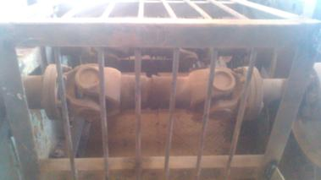

~~Cordon~~ Cardon shaft

1. Replace it with new shaft (Use overhead EOT Crane for removing and replacing new Cardon shaft due to space constraint) and thoroughly check for the damage to the old shaft and take necessary precautions to avoid it for new installed shaft.
2. Tighten all the nut and bolts with torque wrench.
3. Fix all the safety guards prior to start up.
4. Remove all the tools and tackles from the screen area.
5. Clear electrical shut down to take no load trial.

* Check function in running condition
* Check for any abnormal sound or vibrations.
* If found satisfactory give clearance to operation.

1. Clear the work permit and handover screen to operation.

**Work No. 2:** **Replacement of gearbox oil of Sinter Product Screen changing**

1. Obtain the shutdown clearance from Electrical Department.
2. If more than one worker is relying on the protection of an isolation, then all workers should apply their own locks in master lock out box
3. Press local push emergency button of the SCREEN.
4. Drain old gear oil from gearbox (Ensure proper arrangement is done to avoid spillage of oil on ground)
5. fill new gear oil in the gearbox (Shell Omala SP 320)
6. Fix all the safety guards prior to start up.
7. Remove all the tools and tackles from the screen area.
8. Clear electrical shut down to take no load trial.

**Work No. 3:** **Replacement of Sinter Product Screen deck plate**

1. Obtain the shutdown clearance from Electrical Department.
2. If more than one worker is relying on the protection of an isolation, then all workers should apply their own locks in master lock out box
3. Press local push emergency button of the screen.
4. Shift new Screen deck plate to the working area using overhead EOT Crane in screen building.
5. ~~Remove screen cover~~ Open screen inspection door to facilitate the replacement of deck plate.
6. Remove screen mesh bolts & deck plate.
7. Replace it with new deck plate.
8. Tighten the nut and bolts; lock it in its position.
9. Fix all covers and guards.
10. Remove all the tools and tackles from the screen area.
11. Clear electrical shut down & take No Load trial. Check for any abnormalities in running condition.
12. If found satisfactory, clear work permit and handover screen to operation.

**Work No. 4: Replacement of Skirt rubber.**

1. Obtain the shutdown clearance from Electrical Department.
2. If more than one worker is relying on the protection of an isolation, then all workers should apply their own locks in master lock out box
3. Press local push emergency button of the screen.
4. Remove damaged skirting.
5. Replace new skirt rubber.
6. Tight the nut and bolts, lock it in its position.
7. Remove all the tools and tackles from the screen area.
8. Clear electrical shut down & take No Load trial. Check for any abnormalities in running condition.
9. If found satisfactory, clear work permit and handover screen to operation.

**Work No. 5: Replacement of Shock absorber.**

1. Obtain the shutdown clearance from Electrical Department
2. If more than one worker is relying on the protection of an isolation, then all workers should apply their own locks in master lock out box
3. Press local push emergency button of the screen.
4. Shift new Shock absorber to the working area.
5. Remove old Shock absorber.
6. Replace it with new Shock absorber.
7. Tighten the nut and bolts; lock it in its position.
8. Remove all the tools and tackles from the screen area.
9. Clear electrical shut down & take No Load trial. Check for any abnormalities in running condition.
10. If found satisfactory, clear work permit and handover screen to operation.

**Work No. 6: Replacement of spring**

1. Obtain the shutdown clearance from Electrical Department.
2. If more than one worker is relying on the protection of an isolation, then all workers should apply their own locks in master lock out box
3. Press local push emergency button of the screen.
4. Shift new rubber springs to the working area.
5. ~~Locate EOT crane to the position for lifting screen body~~. Use 50Tn hydraulic jack (2nos) to lift the screen body and also use strong packing pieces to distribute load on hydraulic jack as well as a safety measure incase hydraulic jack fails.
6. Lift the screen body where spring to be replaced.
7. Remove damaged spring & replace it with new one.
8. ~~Release the crane load & check the screen position~~. Release hydraulic jack and remove from underneath screen body and check screen position.
9. Remove all the tools and tackles from the screen area.
10. Clear electrical shut down & take No Load trial. Check for any abnormalities in running condition.
11. If found satisfactory, clear work permit and handover screen to operation.

**Work No. 7: Replacement of V belt**

Pl refer WI/MAINT/100

**Work No. 8: Replacement of Counter wt. shaft & bearing**

1. Obtain the shutdown clearance from Electrical Department.
2. If more than one worker is relying on the protection of an isolation, then all workers should apply their own locks in master lock out box
3. Press local push emergency button of the screen.
4. Remove the guards of exciter.
5. Remove distance piece in between counter weight

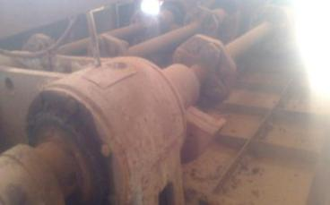

Distance piece

Counter weights

Bearing block

1. Remove ~~Cordon~~ Cardon shaft if drive side exciter/bearings to be replaced.
2. Remove counter weight.
3. Remove bearings which are to be replaced.
4. Clean it properly & replace the bearings with new after checking shaft & bearings dia. tolerances.
5. Assemble bearings &counter weight.
6. Adjust the counter weight
7. Fix the distance piece in between counter weight.
8. Check freeness of bearings by rotating shaft by hand.
9. Fix guards.
10. Remove all the tools and tackles from the screen area.
11. Clear electrical shut down & take No Load trial. Check for any abnormalities in running condition.
12. If found satisfactory, clear work permit and handover screen to operation.

**Work no. 9: Assembly of Exciter**

1. Remove counter wt. Locking bolts
2. Remove ~~selves~~ sleeves carefully both side
3. Remove counter wt. both side
4. Remove slip ring & bearing end cover
5. Remove bearings assembly
6. Clean it properly & check shaft & bearings dia. tolerances.
7. Fix new bearings assembly
8. Fix end cover with slip ring
9. Fix counter weight, assure all counter weights are equal
10. Adjust the counter weight
11. Check freeness of bearings by rotating shaft by hand.
12. Fill grease assembly of exciter.

**Work No. 10: Replacement of Counter Weight of Exciter assembly**

1. Obtain the shutdown clearance from Electrical Department.
2. If more than one worker is relying on the protection of an isolation, then all workers should apply their own locks in master lock out box
3. Press local push emergency button of the screen.
4. Remove the guards of exciter.
5. Remove Cardon shaft
6. Remove distance piece in between counter weight and cardon shaft
7. Remove counter weight. (Use hydraulic jack and puller bracket to remove counter weight from shaft and use overhead EOT crane to dismantle/hold/refit cardon shaft, distance piece and counter weight as shown in below pictures)

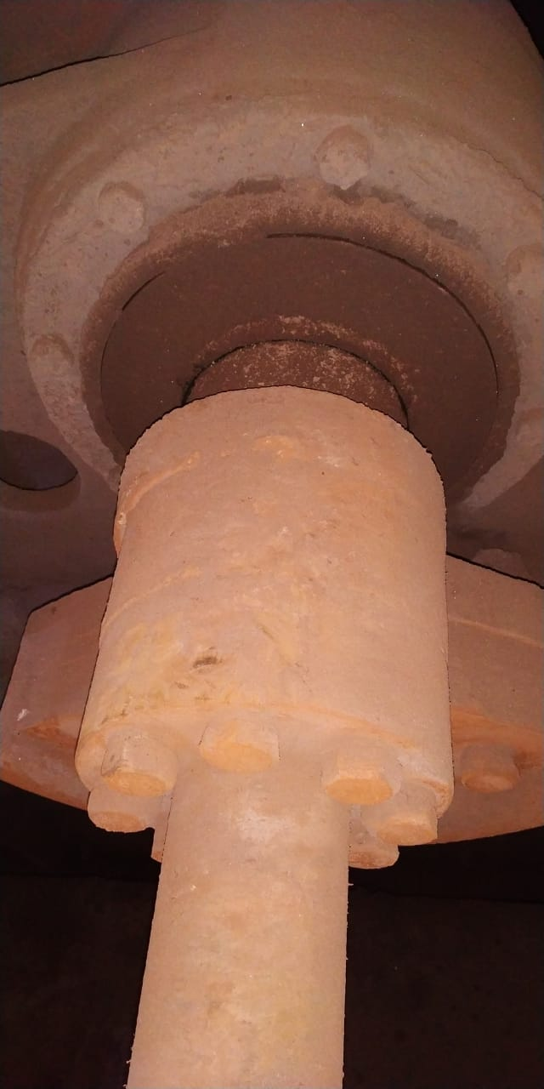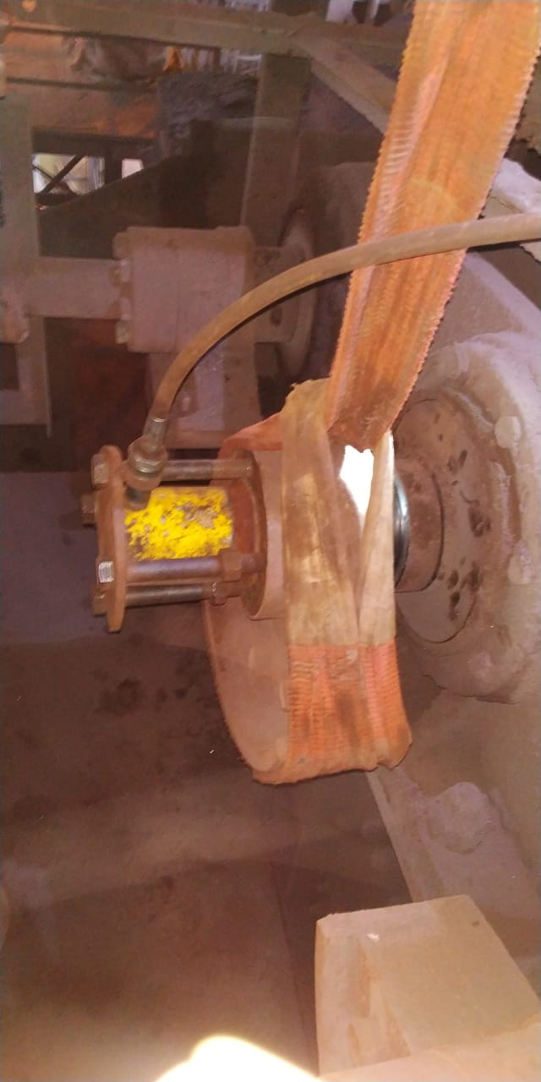

1. Replace new counter weight
2. Refit distance piece
3. Connect back and assemble removed cardon shaft
4. Check freeness of bearings by rotating shaft by hand.
5. Fix guards.

13. Remove all the tools and tackles from the screen area.

1. Clear electrical shut down & take No Load trial. Check for any abnormalities in running condition.
2. If found satisfactory, clear work permit and handover screen to operation.

**Amendement Record**

|  |  |  |  |
| --- | --- | --- | --- |
| **Date** | **Manual Section Ref. & Para** | **Brief details of Revision** | **New Rev.** |
|  |  |  |  |
|  |  |  |  |
|  |  |  |  |

|  |  |  |
| --- | --- | --- |
| Prepared By:  Ass. Manager – Sinter Plant | Reviewed & Issued By:  Management Representative | Approved By:  Head Sinter Plant |
| Signature: | Signature: | Signature: |
| Review Date: 25.09.2022 | Review Date: 25.09.2022 | Review Date: 25.09.2022 |